UDC (required)
doi: (leave blank)
Ivan I. Ivanov*, Firstname P. Lastname
Affiliation
*e-mail
Firstname P. Lastname
Affiliation (if authors have different affiliations)
TITLE
Abstract. A single paragraph of up to approximately 200 words.
Keywords: keyword 1, keyword 2, keyword 3.
Subheading
References should be numbered in the order of appearance and indicated by numerals in square brackets, for example [1], [2,3], or [4–6].
Bullet lists should be formatted as follows:
- First item;
- Second item;
- Third item.
Numbered lists should be formatted as follows:
- First item;
- Second item;
- Third item.
The text continues here.
All figures and tables must be referenced in the main text as Figure 1, Table 1, etc.
Table 1
Table title
Text | Text | Text
Text | Text | Text
Text | Text | Text
Text | Text | Text
The text continues here.
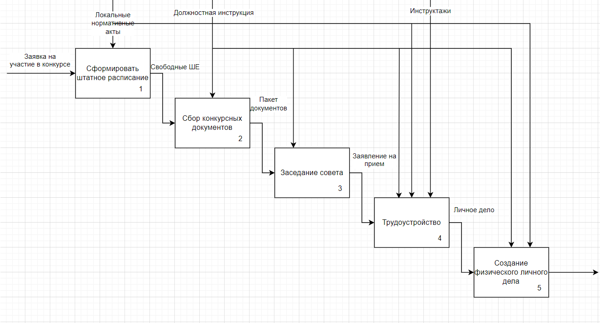
Figure 1 – Caption
The text continues here.
References
(formatted according to GOST standards)
- Source 1.
- Source 2.
- Source 3.
…
- Source 12.

